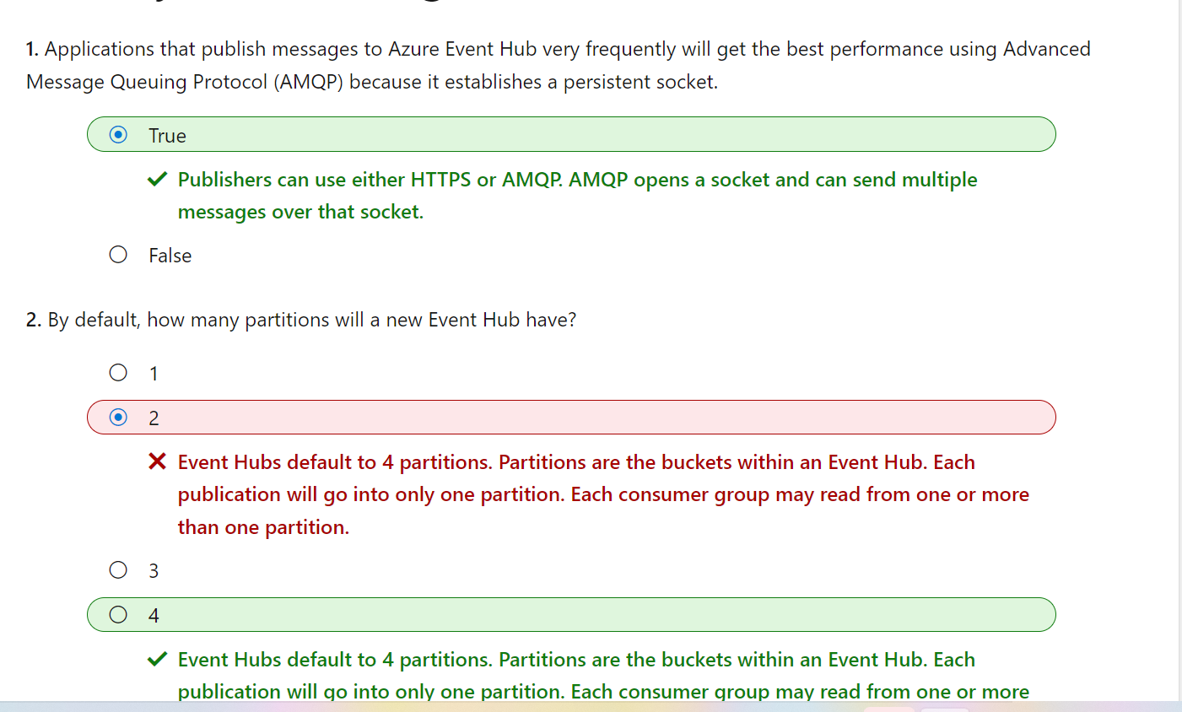

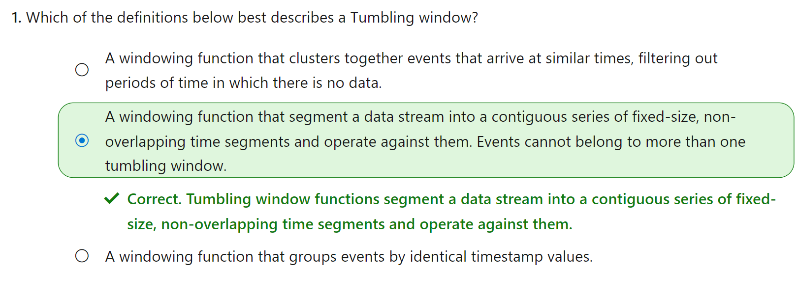

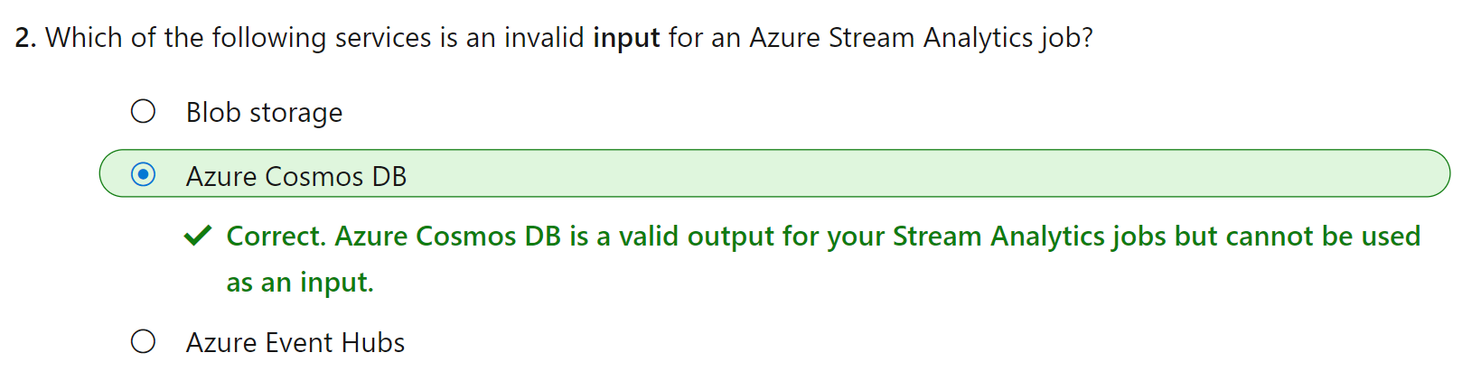

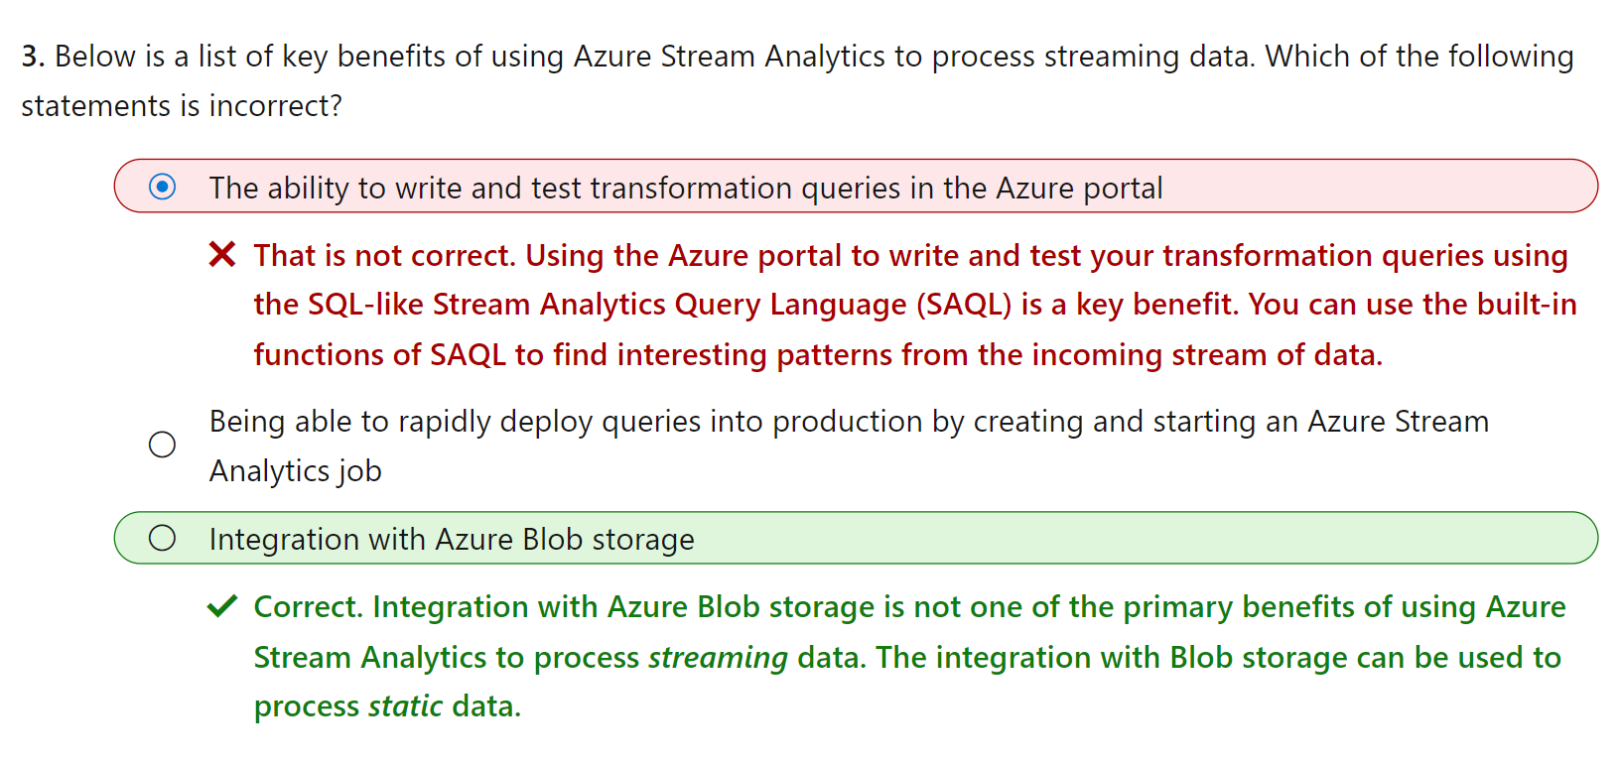

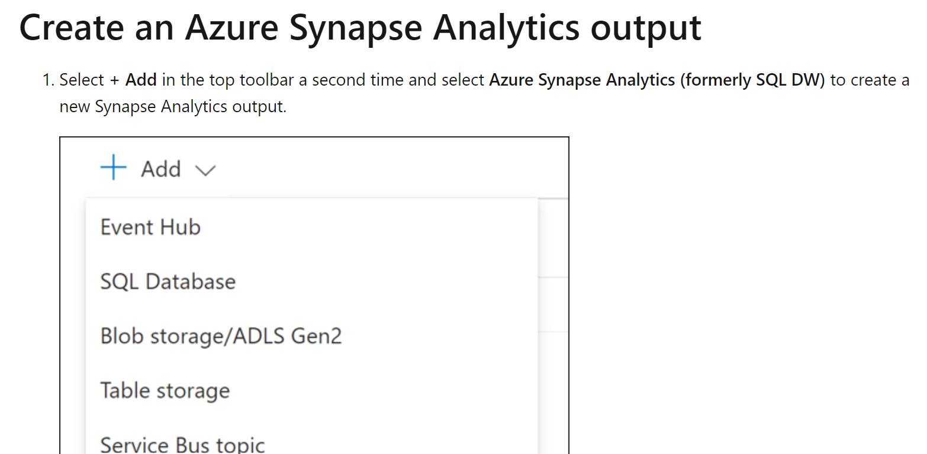

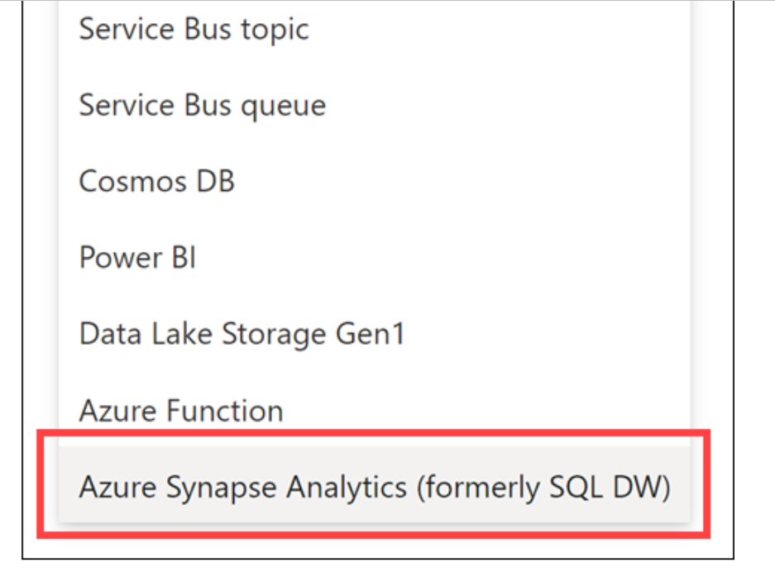

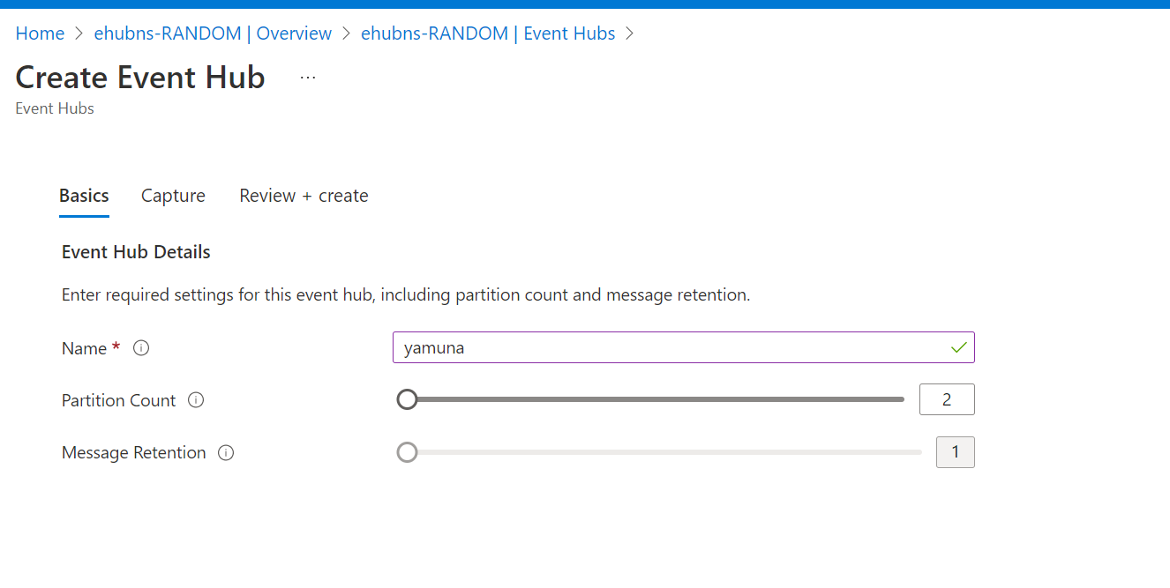

JSON

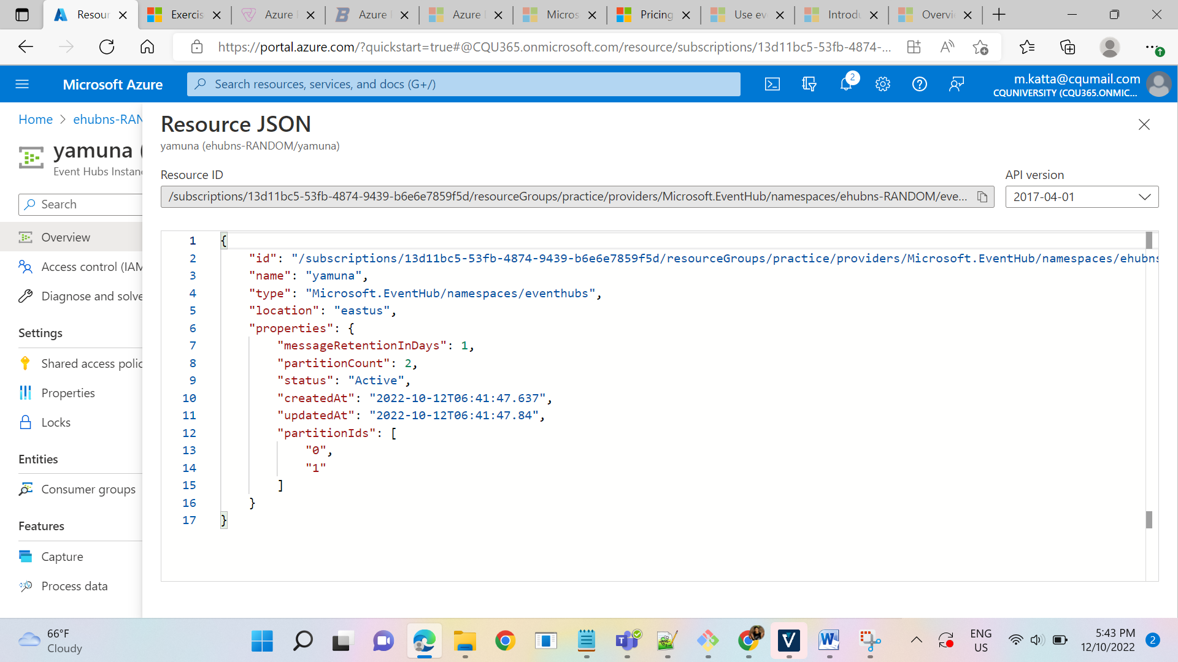



After event creation see the following options to process event hubs using the below:

Capture Data into Gen2 in parquet format, Synapse SQL, Cosmos DB,

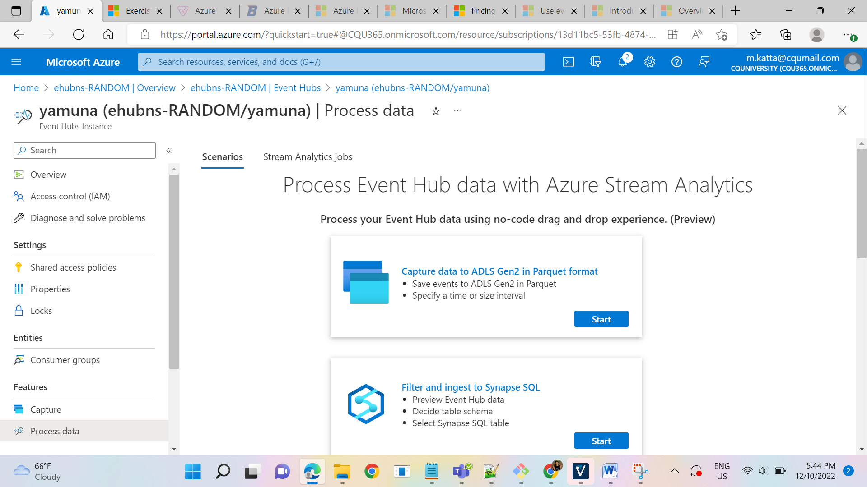

Capture Data into GEN2 in parquet format

* Save events to ADLS GEN2 in Parquet
* Specify a time or size interval

Filter and ingest to Synapse SQL

* Preview Event Hub data
* Decide table schema
* Select Synapse SQL table

Materialize data in Cosmos DB

* Maintain a view of your data in cosmos DB
* Select the fields to be groupby
* Define aggregations like count, sum, average
* Set a time period

Filter and ingest to ADLS GEN2

* Preview Event Hub data
* Decide table schema
* Select ADLS GEN2 account

Process your query’s using Streaming Analytics Query Language:

* Enable real time insights from events
* Preview Event Hub data
* Analyze your data using SQL-like query
* Deploy query by creating a new Azure Stream Analytics job

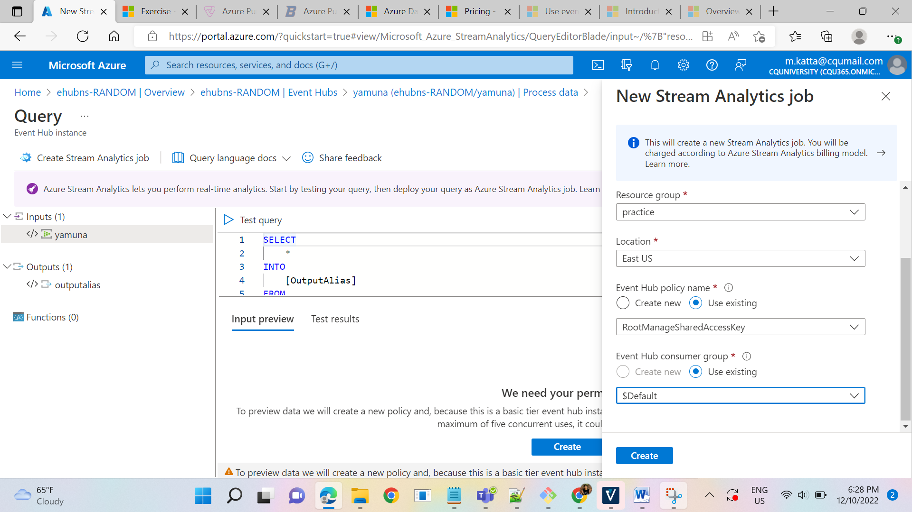

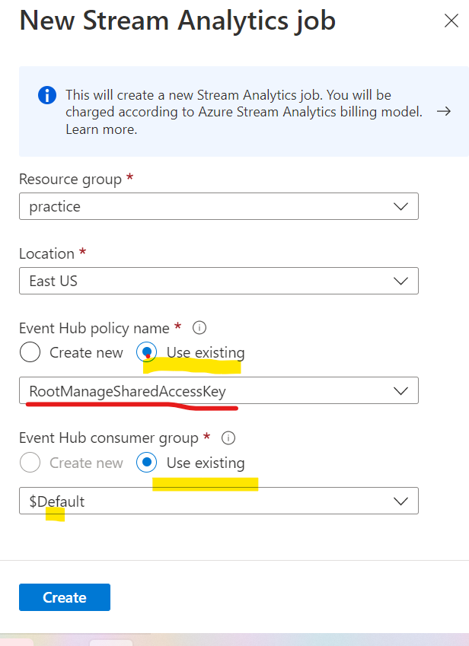

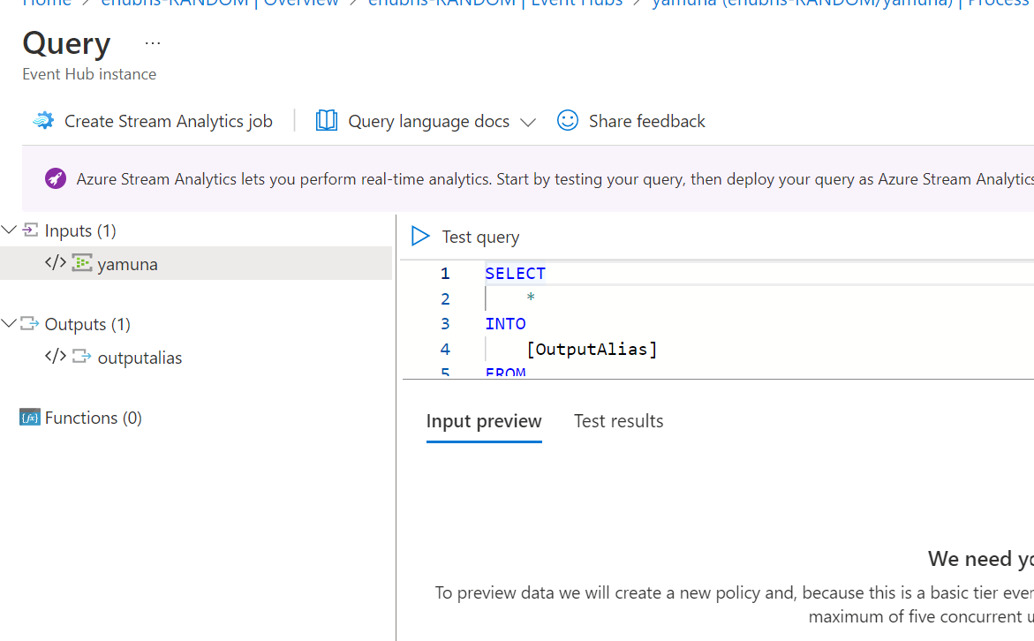

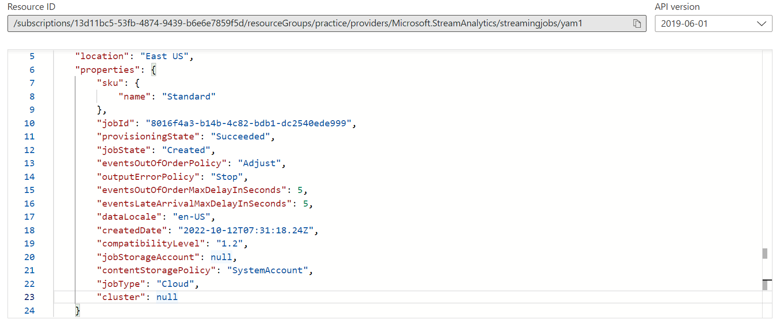

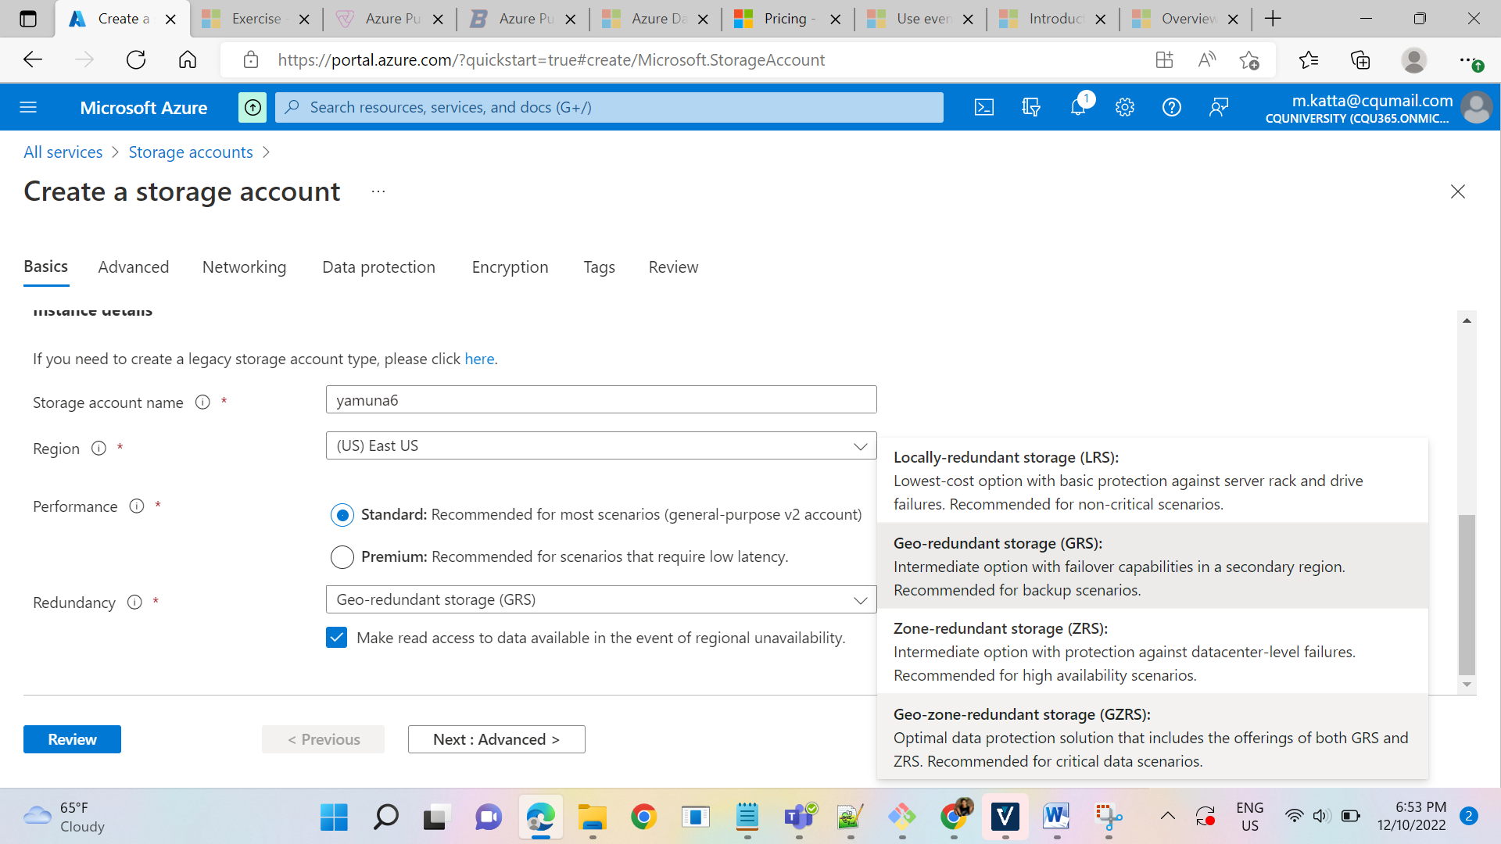

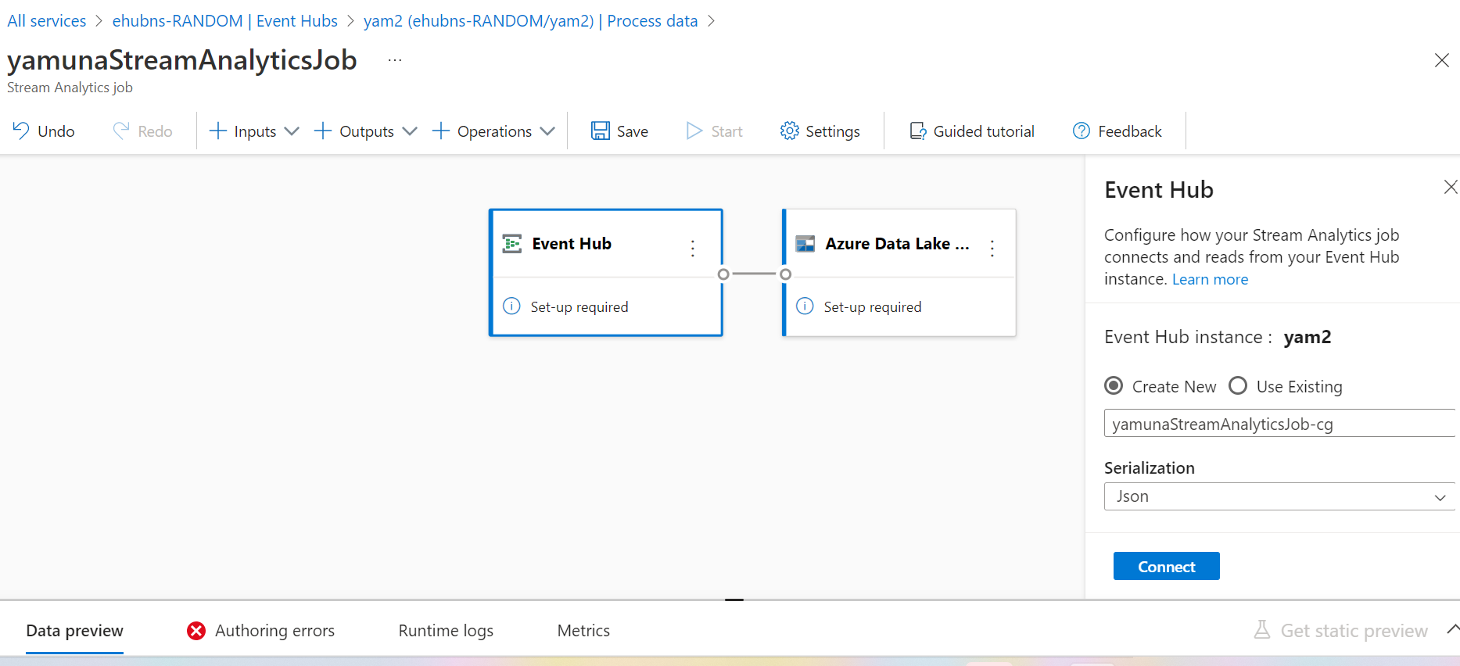

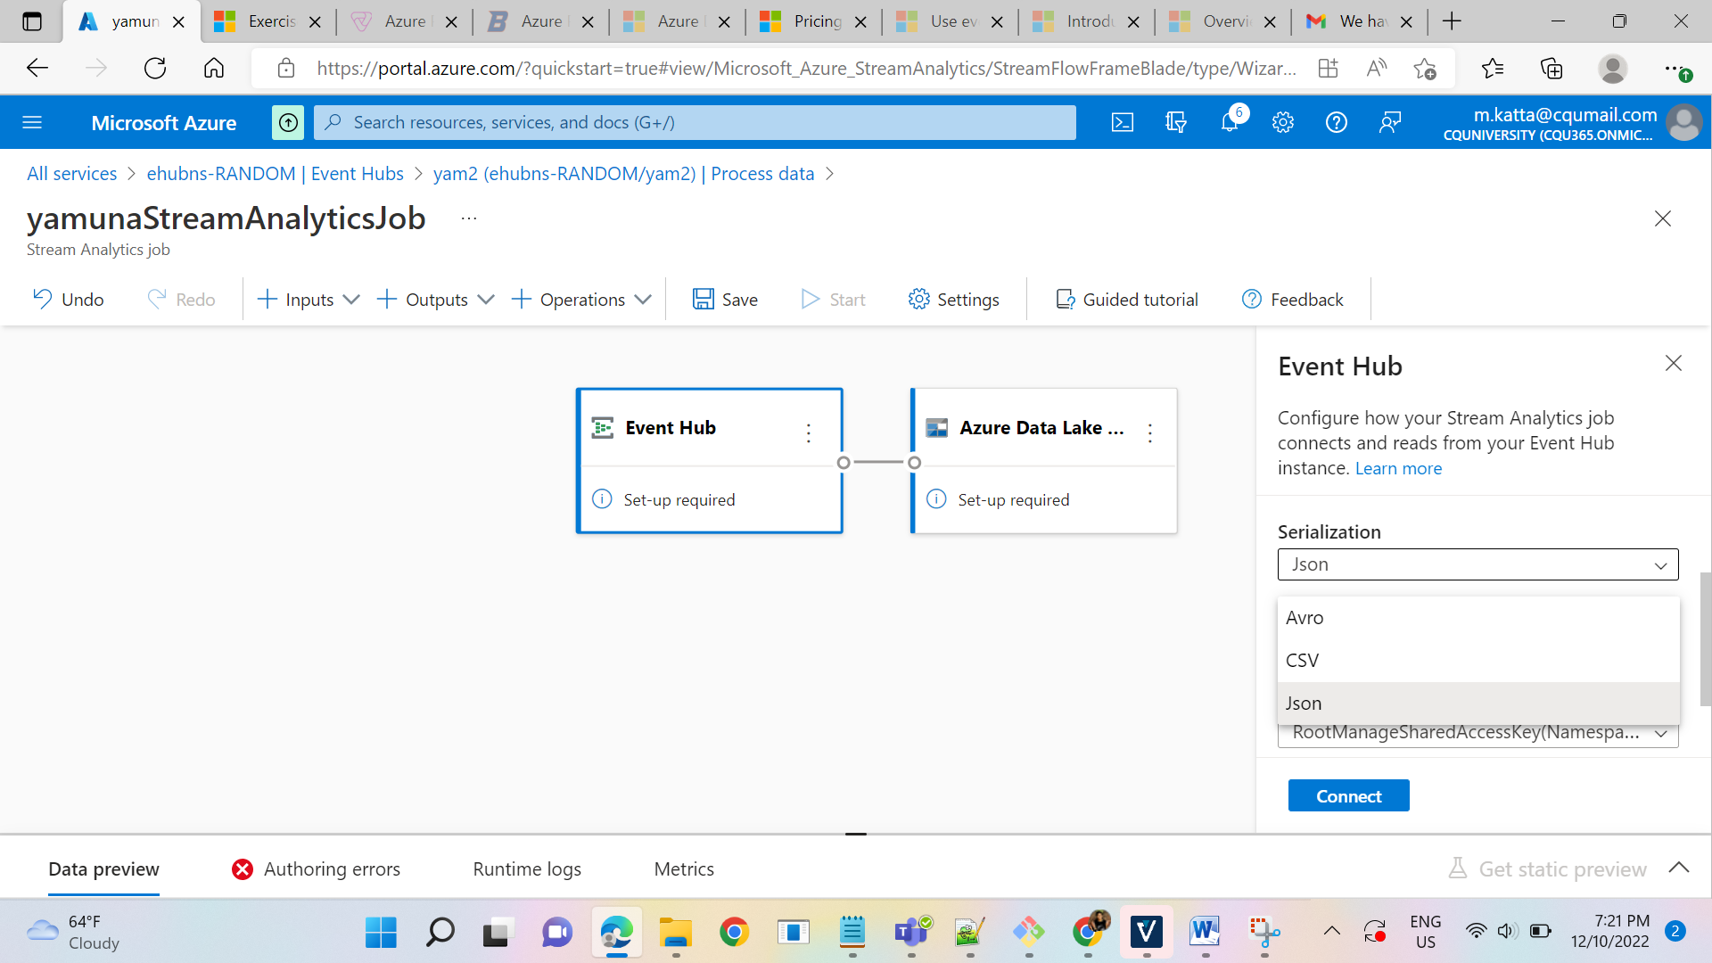

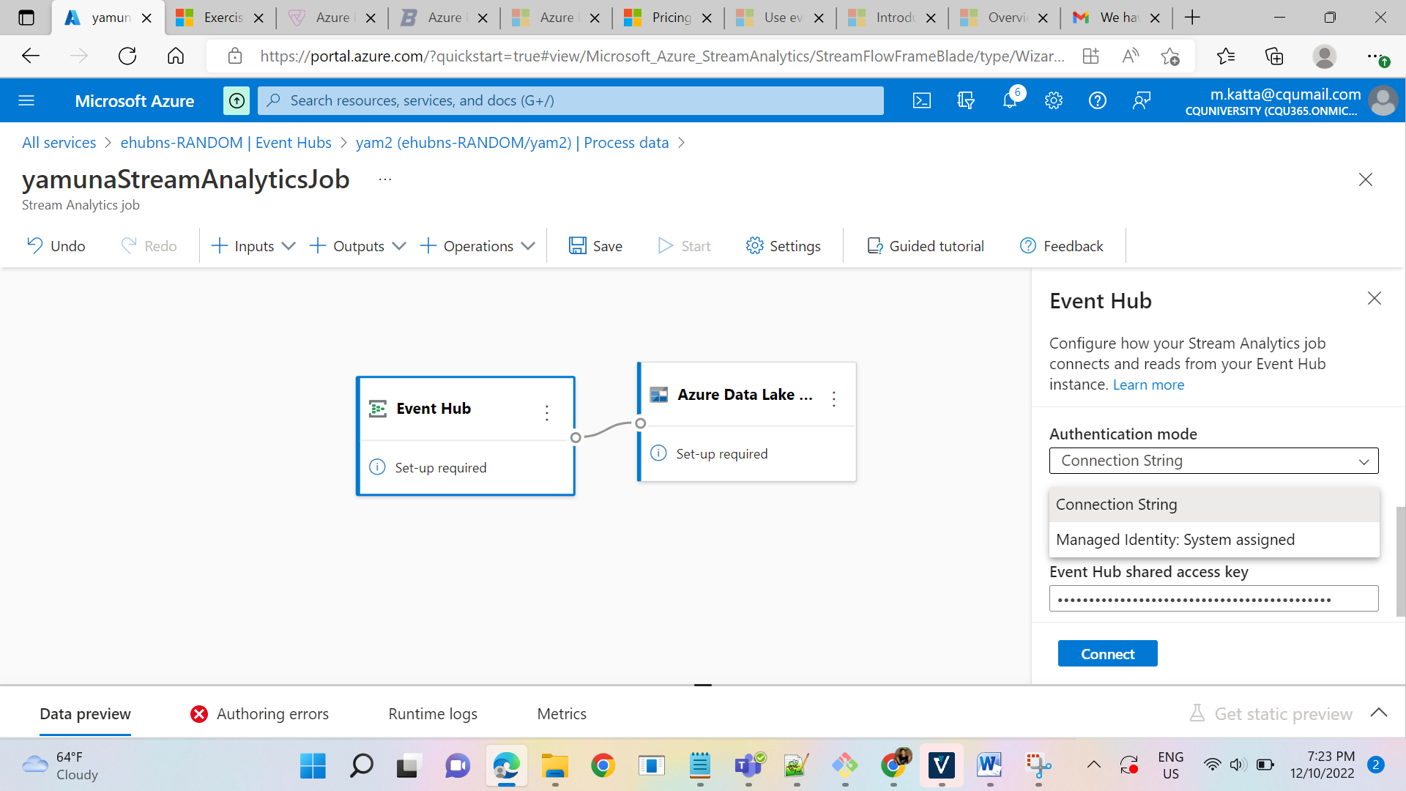

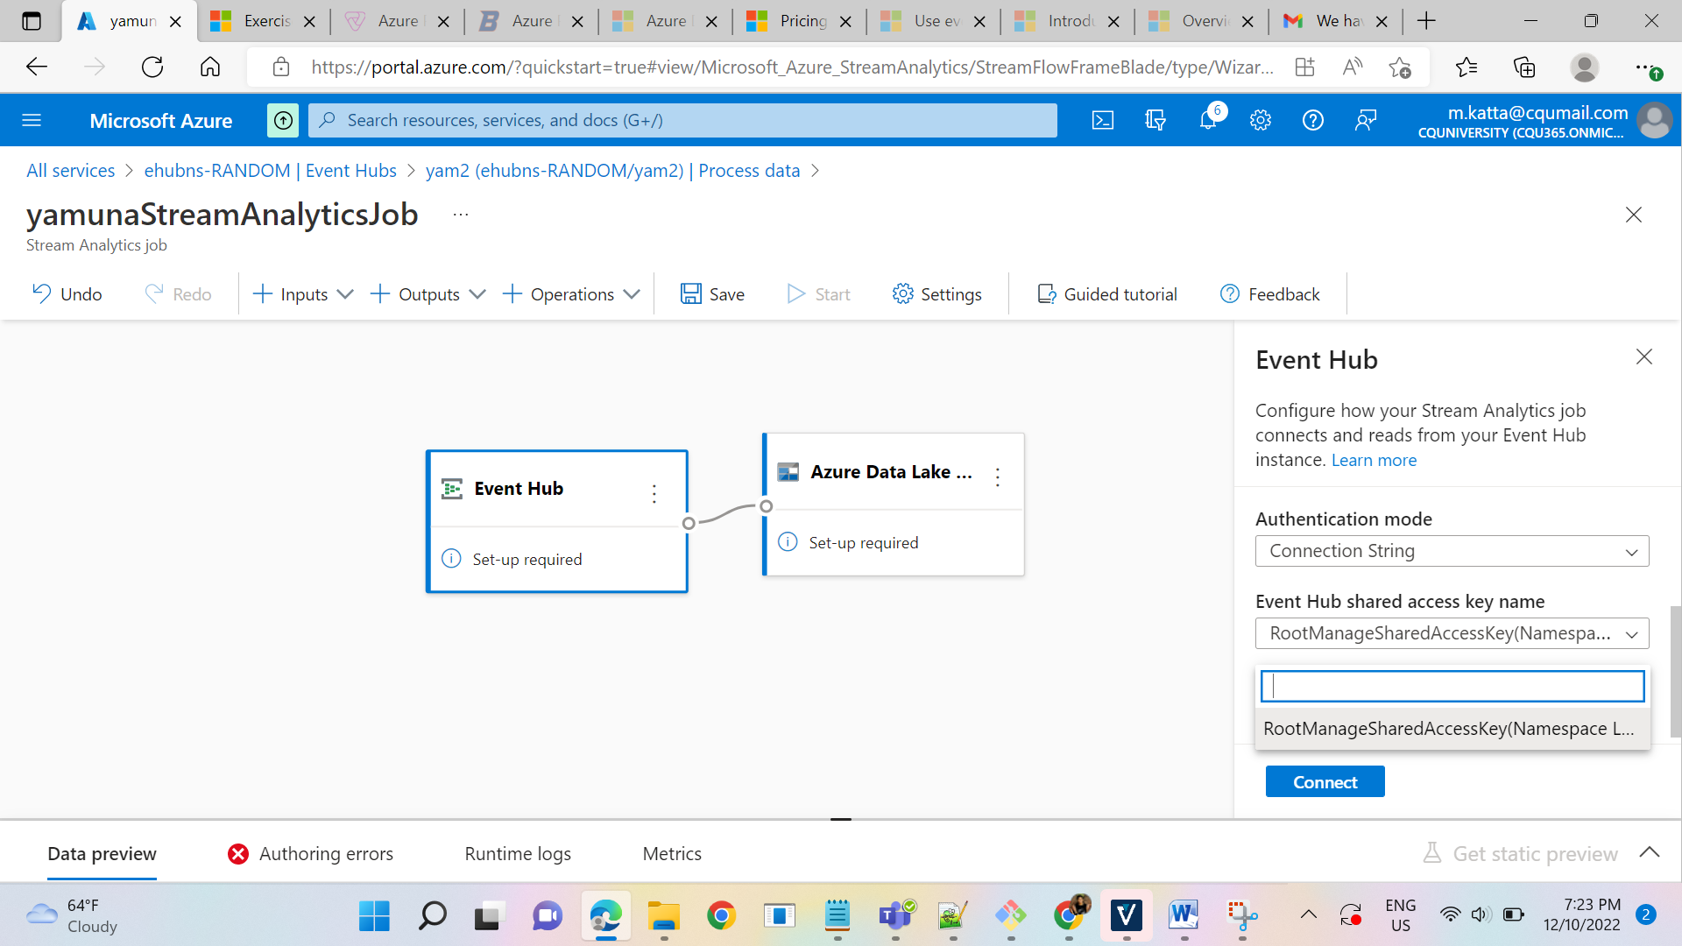

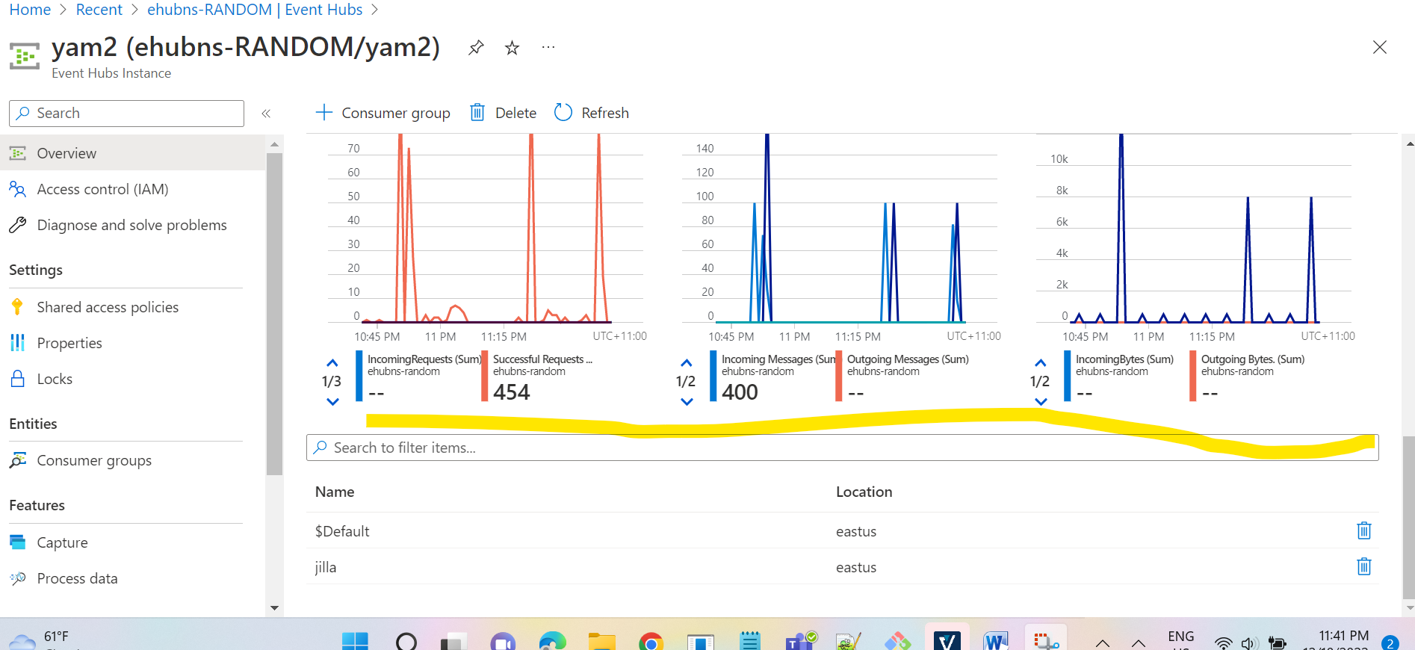

**TUMBLING WINDOW:**

SELECT EventName, COUNT(*) AS Count

FROM EventStream TIMESTAMP BY EventTimestamp

GROUP BY EventName, TumblingWindow(minute, 10)

**HOPPING WINDOW:**

-- Count the number of times each event occurs every 10 seconds

SELECT EventName, COUNT(*) AS Count

FROM EventStream TIMESTAMP BY EventTimestamp

GROUP BY EventName, HoppingWindow(second, 10, 5)

**SLIDING WINDOW:**

SELECT

DateAdd(minute,-5,System.Timestamp()) AS WinStartTime,

System.Timestamp() AS WinEndTime,

EventName,

COUNT(*) AS Count

FROM EventStream TIMESTAMP BY EventTimestamp

GROUP BY EventName, SlidingWindow(minute, 10)

HAVING COUNT(*) > 3